SEC Form 3
FORM 3 | UNITED STATES SECURITIES AND EXCHANGE COMMISSION  Washington, D.C. 20549  INITIAL STATEMENT OF BENEFICIAL OWNERSHIP OF SECURITIES  Filed pursuant to Section 16(a) of the Securities Exchange Act of 1934  or Section 30(h) of the Investment Company Act of 1940
  OMB APPROVAL
  OMB Number: | 3235-0104
  Estimated average burden
  hours per response: | 0.5
1. Name and Address of Reporting Person*  (Street) | 2. Date of Event Requiring Statement (Month/Day/Year)  10/16/2026 | 3. Issuer Name and Ticker or Trading Symbol  SUJA LIFE, INC. [ SUJA ]  Foreign Trading Symbol
  Engel Robert B
  (Last) | (First) | (Middle)
  C/O SUJA LIFE, INC.
  3831 OCEAN RANCH BLVD.
  OCEANSIDE | CA | 92056
  (City) | (State) | (Zip)
 |  | 4. Relationship of Reporting Person(s) to Issuer  (Check all applicable) | 5. If Amendment, Date of Original Filed (Month/Day/Year)
   | Director |  | 10% Owner
   | Officer (give title below) |  | Other (specify below)
6. Individual or Joint/Group Filing (Check Applicable Line)
Form filed by One Reporting Person
Form filed by More than One Reporting Person

Table I - Non-Derivative Securities Beneficially Owned
1. Title of Security (Instr. 4) | 2. Amount of Securities Beneficially Owned (Instr. 4) | 3. Ownership Form: Direct (D) or Indirect (I) (Instr. 5) | 4. Nature of Indirect Beneficial Ownership (Instr. 5)
Class A Common Stock | 5,000 | D
Table II - Derivative Securities Beneficially Owned
(e.g., puts, calls, warrants, options, convertible securities)
1. Title of Derivative Security (Instr. 4) | 2. Date Exercisable and Expiration Date (Month/Day/Year) |  | 3. Title and Amount of Securities Underlying Derivative Security (Instr. 4) |  | 4. Conversion or Exercise Price of Derivative Security | 5. Ownership Form: Direct (D) or Indirect (I) (Instr. 5) | 6. Nature of Indirect Beneficial Ownership (Instr. 5)
1. Title of Derivative Security (Instr. 4) | Date Exercisable | Expiration Date | Title | Amount or Number of Shares | 4. Conversion or Exercise Price of Derivative Security | 5. Ownership Form: Direct (D) or Indirect (I) (Instr. 5) | 6. Nature of Indirect Beneficial Ownership (Instr. 5)
Explanation of Responses:
Remarks:
Exhibit 24.1 - Power of Attorney
 | /s/ Aneta Ferguson, as Attorney-in-fact | 10/20/2026
 | ** Signature of Reporting Person | Date
Reminder: Report on a separate line for each class of securities beneficially owned directly or indirectly.
* If the form is filed by more than one reporting person, see Instruction 5 (b)(v).
** Intentional misstatements or omissions of facts constitute Federal Criminal Violations See 18 U.S.C. 1001 and 15 U.S.C. 78ff(a).
Note: File three copies of this Form, one of which must be manually signed. If space is insufficient, see Instruction 6 for procedure.
Persons who respond to the collection of information contained in this form are not required to respond unless the form displays a currently valid OMB Number.
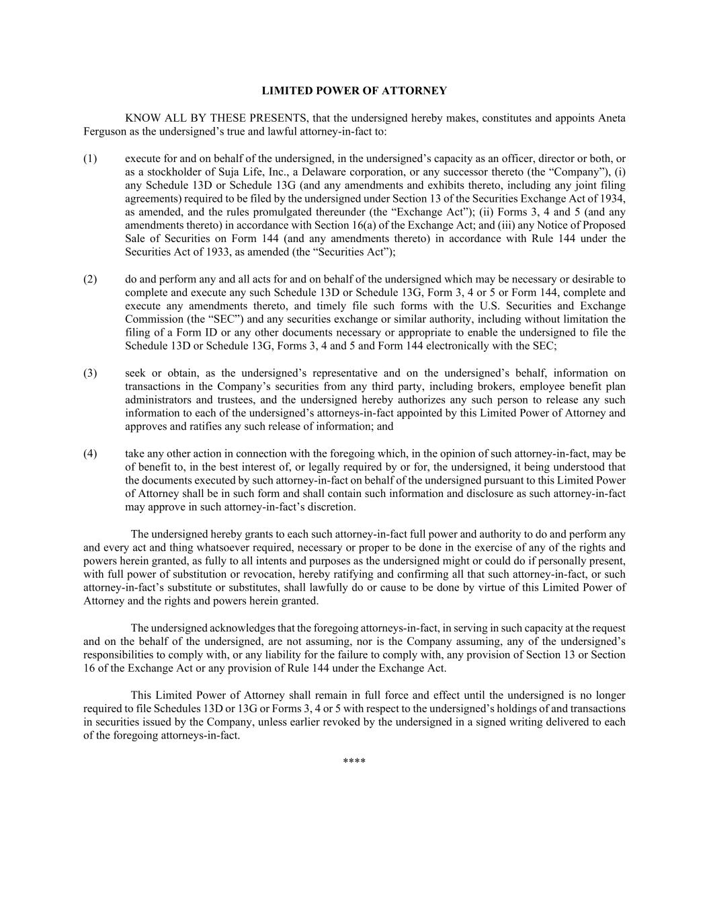
LIMITED POWER OF ATTORNEY KNOW ALL BY THESE PRESENTS, that the undersigned hereby makes, constitutes and appoints Aneta Ferguson as the undersigned’s true and lawful attorney-in-fact to: (1) execute for and on behalf of the undersigned, in the undersigned’s capacity as an officer, director or both, or as a stockholder of Suja Life, Inc., a Delaware corporation, or any successor thereto (the “Company”), (i) any Schedule 13D or Schedule 13G (and any amendments and exhibits thereto, including any joint filing agreements) required to be filed by the undersigned under Section 13 of the Securities Exchange Act of 1934, as amended, and the rules promulgated thereunder (the “Exchange Act”); (ii) Forms 3, 4 and 5 (and any amendments thereto) in accordance with Section 16(a) of the Exchange Act; and (iii) any Notice of Proposed Sale of Securities on Form 144 (and any amendments thereto) in accordance with Rule 144 under the Securities Act of 1933, as amended (the “Securities Act”); (2) do and perform any and all acts for and on behalf of the undersigned which may be necessary or desirable to complete and execute any such Schedule 13D or Schedule 13G, Form 3, 4 or 5 or Form 144, complete and execute any amendments thereto, and timely file such forms with the U.S. Securities and Exchange Commission (the “SEC”) and any securities exchange or similar authority, including without limitation the filing of a Form ID or any other documents necessary or appropriate to enable the undersigned to file the Schedule 13D or Schedule 13G, Forms 3, 4 and 5 and Form 144 electronically with the SEC; (3) seek or obtain, as the undersigned’s representative and on the undersigned’s behalf, information on transactions in the Company’s securities from any third party, including brokers, employee benefit plan administrators and trustees, and the undersigned hereby authorizes any such person to release any such information to each of the undersigned’s attorneys-in-fact appointed by this Limited Power of Attorney and approves and ratifies any such release of information; and (4) take any other action in connection with the foregoing which, in the opinion of such attorney-in-fact, may be of benefit to, in the best interest of, or legally required by or for, the undersigned, it being understood that the documents executed by such attorney-in-fact on behalf of the undersigned pursuant to this Limited Power of Attorney shall be in such form and shall contain such information and disclosure as such attorney-in-fact may approve in such attorney-in-fact’s discretion. The undersigned hereby grants to each such attorney-in-fact full power and authority to do and perform any and every act and thing whatsoever required, necessary or proper to be done in the exercise of any of the rights and powers herein granted, as fully to all intents and purposes as the undersigned might or could do if personally present, with full power of substitution or revocation, hereby ratifying and confirming all that such attorney-in-fact, or such attorney-in-fact’s substitute or substitutes, shall lawfully do or cause to be done by virtue of this Limited Power of Attorney and the rights and powers herein granted. The undersigned acknowledges that the foregoing attorneys-in-fact, in serving in such capacity at the request and on the behalf of the undersigned, are not assuming, nor is the Company assuming, any of the undersigned’s responsibilities to comply with, or any liability for the failure to comply with, any provision of Section 13 or Section 16 of the Exchange Act or any provision of Rule 144 under the Exchange Act. This Limited Power of Attorney shall remain in full force and effect until the undersigned is no longer required to file Schedules 13D or 13G or Forms 3, 4 or 5 with respect to the undersigned’s holdings of and transactions in securities issued by the Company, unless earlier revoked by the undersigned in a signed writing delivered to each of the foregoing attorneys-in-fact. ****

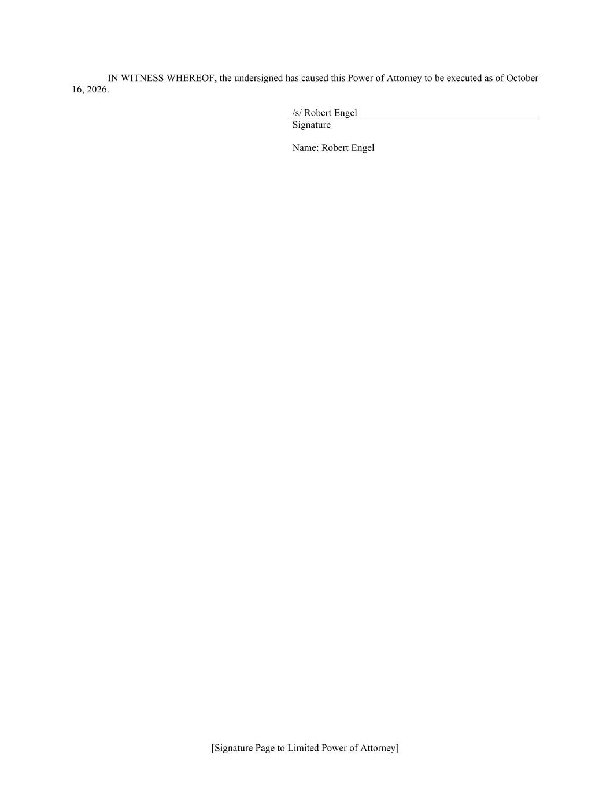
[Signature Page to Limited Power of Attorney] IN WITNESS WHEREOF, the undersigned has caused this Power of Attorney to be executed as of October 16, 2026. /s/ Robert Engel Signature Name: Robert Engel

